 | University of Missouri – Columbia  Department of Electrical Engineering & Computer Science
Outdoor Solar Powered Lighting Installation for Unpowered Structures
ECE Capstone Project – Proposed Implementation
September 28, 2020
— Engineering Team —
Matt Soehngen, Electrical Engineering, Physics
Nicholas Erickson, Electrical and Computer Engineering
Sterling LaBarbera, Computer Engineering

— Course Instructor —
Mr. Jim Fischer

Proposed Implementation

Ideation
By Nicholas Erickson

For our capstone design project, our group wanted to focus on utilizing a renewable energy source to help solve a problem or improve an existing product. We decided it would be an interesting idea to use solar energy to power an outdoor LED strip to be used for social gatherings. When we were thinking of ways to implement our idea, we brainstormed that it would be a nice addition to attach a mosquito repellent tone to deter mosquitos while enjoying your time outside. When thinking about the practicality of our product, we wanted the user to have the ability to change the colors and have the lights pulse to outdoor music if desired. When thinking of a way to implement these ideas we decided we could develop an app for a smartphone to control the colors of the LEDs and the output mode for the user. This would allow the user the ability to fully remotely control the LED lights by changing the mode through their phone. In order to implement this idea we decided to connect the smartphone to a controller which would connect to the LED lights. When thinking about our products outdoor intended use, we brainstormed that it would be a nice addition to attach a mosquito repellent tone to deter mosquitoes from visiting while enjoying your time outside.

Proposed Implementation
Our proposed implementation for our capstone project is to power an outdoor LED strip with a solar charged battery. Our LED strip will be remotely controlled through a bluetooth app with settings to change the colors and modulate to outdoor music. Additionally, our device will be attached with a mosquito repellent circuit.

Theory of Operation

Product Concept Diagrams
By Matt Soehngen
This diagram shows the intended locations of the solar panel, rechargeable battery pack, ultrasound-producing pest deterrent device, and lighting strip on a gazebo. The controller sending signals to the lighting strip will be connected between the battery and the lighting strip, while the ultrasonic buzzer module can be connected directly to the battery.
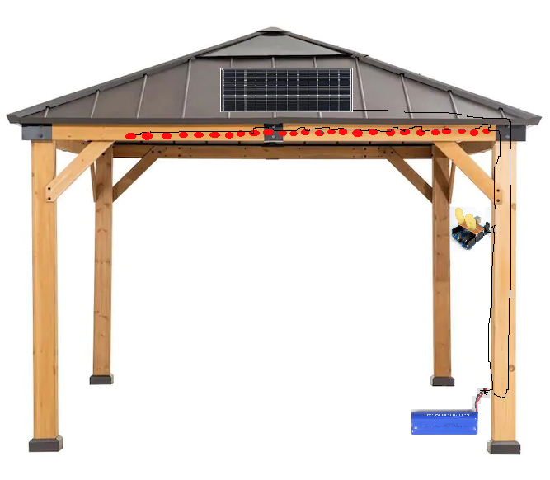

Functional Block Diagrams
By Sterling LaBarbera

Unit 1 – Solar Charged Outdoor Lighting
Our Lighting installation will provide up to 4 hours of lighting from the battery source. The battery will charge during the day via solar panels mounted to the roof of the structure. There will be app control for different light settings and intensities. This unit will also feature a mosquito repellent circuit that produces a high frequency audio tone.
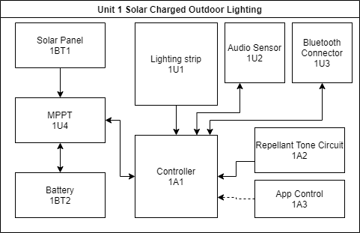

1BT1 – Solar Panel
This will be a purchased solar panel attached to 1U3 via its provided wiring.

1U3 – Maximum Power Point Tracker (MPPT)
The MPPT will also be purchased due to complexity. It provides regulated output from the unregulated Solar panel. It also functions with the battery as a charger.

1BT2 – Battery
The battery is purchased and stores solar power for nighttime operation.

1U1 – Lighting Strip
We will be purchasing LED strip Lighting with color/intensity control to allow our software features to function.

1A1 – Controller
The controller will consist of an Arduino running custom software that can modify the lighting with various audio from the environment via the sensor.

1U2 – Audio Sensor
A simple audio sensor will provide input for the visualization software to modulate the lighting with music. This will be a purchased sensor compatible with the Arduino.

1U3 – Bluetooth Connector
A purchased Bluetooth adapter for the Arduino. Our App will connect via Bluetooth.

1A2 – Mosquito Repellent Tone Circuit
We will build and attach a circuit that emits a high pitched tone known to repel mosquitos. It will be controlled via the app software as well, but is only an on/off element.

1A3 – App Control
This app will have various controls for intensity, color, audio synchronization, and power for the full system and separately for the repellent circuit and the lighting. It will connect via Bluetooth.

Software Architecture
Nicholas Erickson
For our project, we will develop an android app that will be used to send signals to the bluetooth receiver. The app will contain an interface to change the color of the leds, flash the lights, and turn on and off the music mode to have the lights strobe to the music. Our arduino controller will be connected to an audio sensor in order to receive and react to various frequencies. Based on the signals that are received by our controller, the arduino will turn off the output voltage when the sensor detects a loud audio signal.
Light Signal API
Audio sensor | Bluetooth receiver

Work Assignments
By Matt Soehngen
Table 1. Group member assignments: unit assemblies.
Assembly Reference Designation | Assembly Name | COTS? | Assigned To
1A2 | Repellant Tone Circuit | N | Matt Soehngen
1U3 | Smartphone Bluetooth App Connection | N | Nicholas Erickson
1U1 | Lighting Strip | Y | Matt Soehngen
1U2 | Audio Sensor | Y | Sterling Labarbera
1U4 | Maximum Power Point Tracker | N | Sterling Labarbera
1A1 | Controller | N | Nicholas Erickson
1BT1 | Solar Panel | Y | Sterling Labarbera
1BT2 | Rechargeable Battery | Y | Sterling Labarbera

